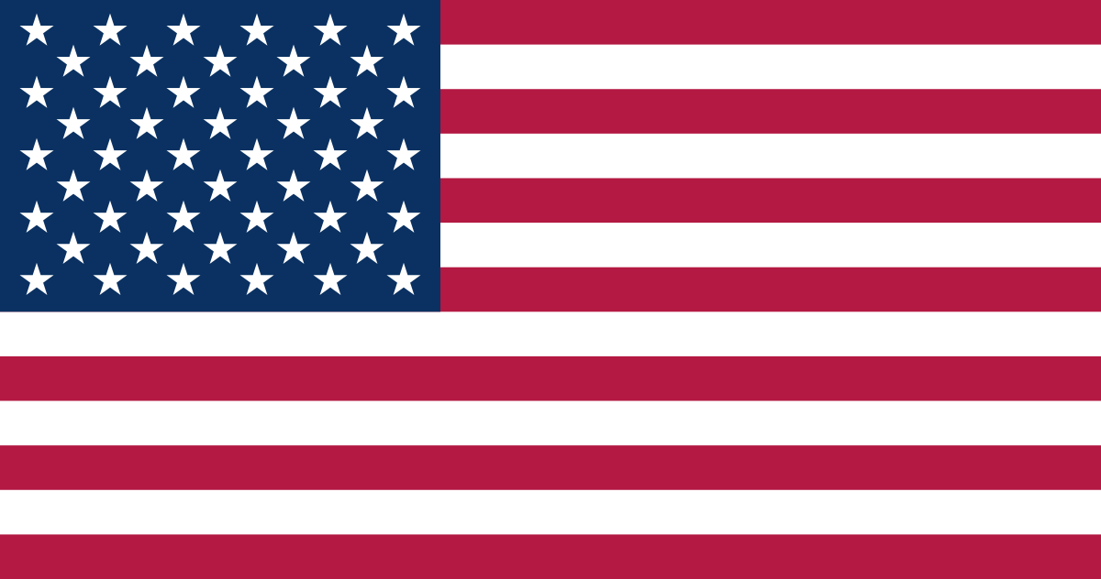 | UNITED STATES OF AMERICA

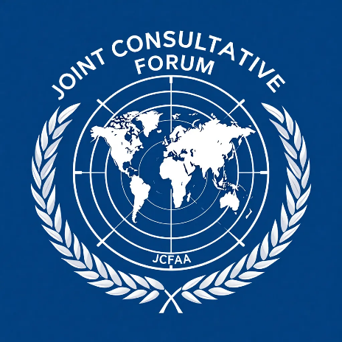 | SECMUN MOCK CONFERENCE 2025 | 

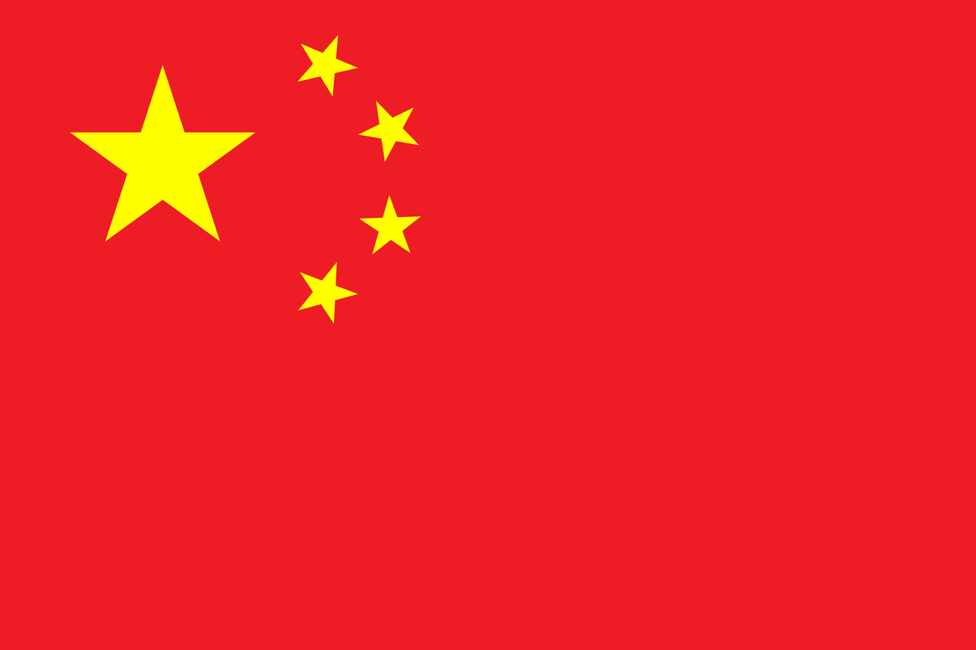 | PEOPLE’S REPUBLIC OF CHINA

 | SECMUN MOCK CONFERENCE 2025 | 

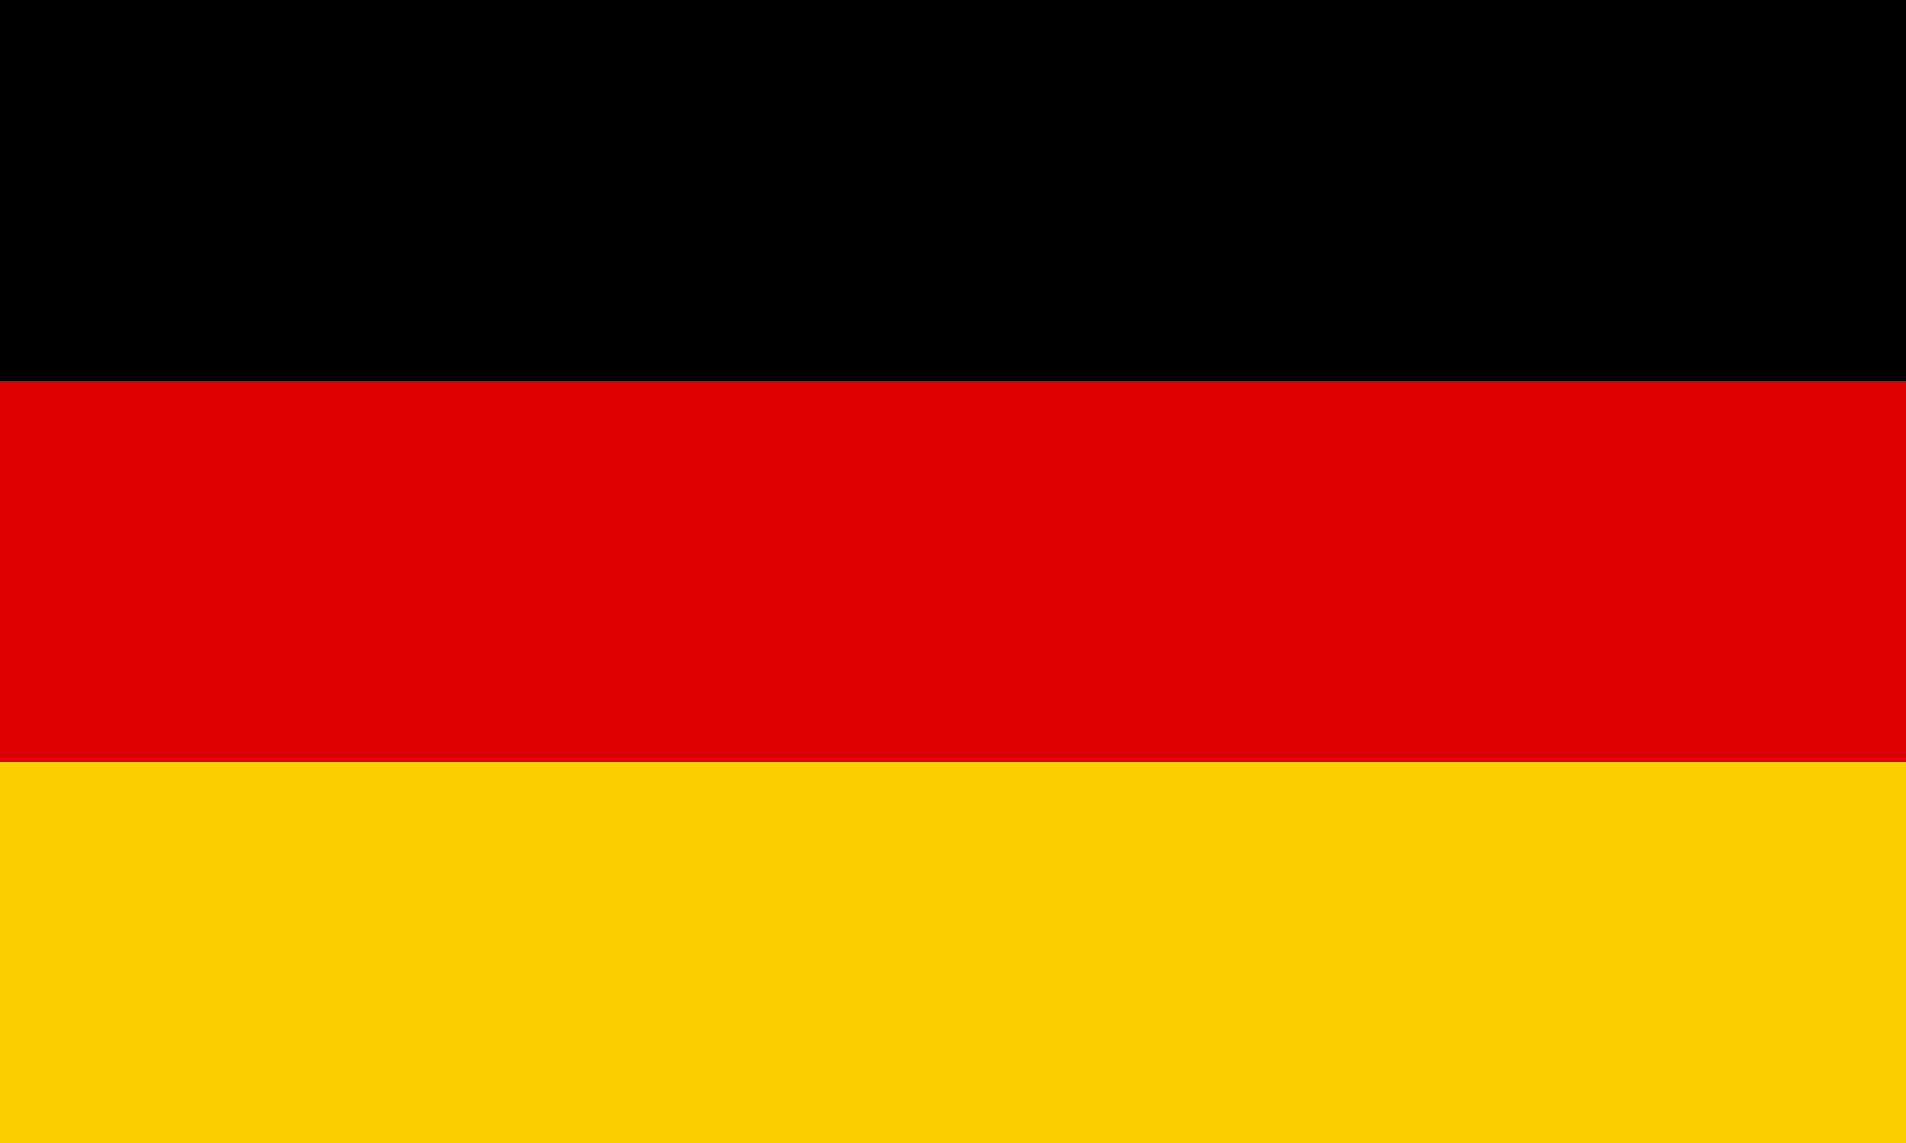 | FEDERAL REPUBLIC OF GERMANY

 | SECMUN MOCK CONFERENCE 2025 | 

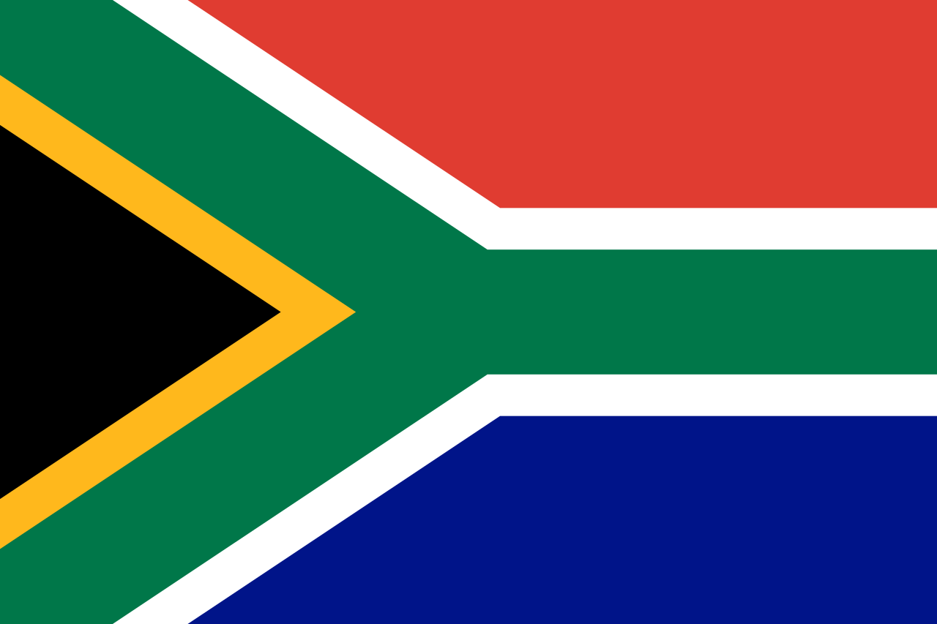 | REPUBLIC OF SOUTH AFRICA

 | SECMUN MOCK CONFERENCE 2025 | 

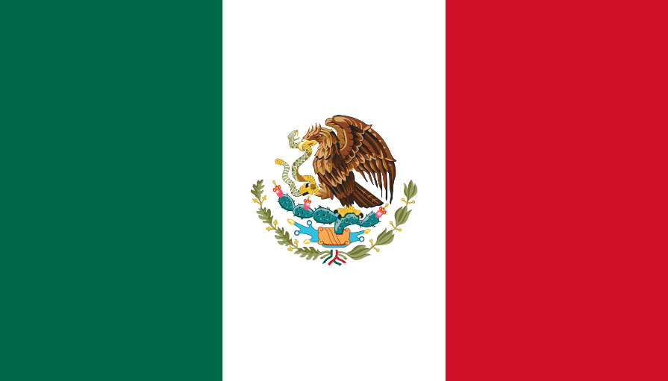 | UNITED MEXICAN STATES

 | SECMUN MOCK CONFERENCE 2025 | 

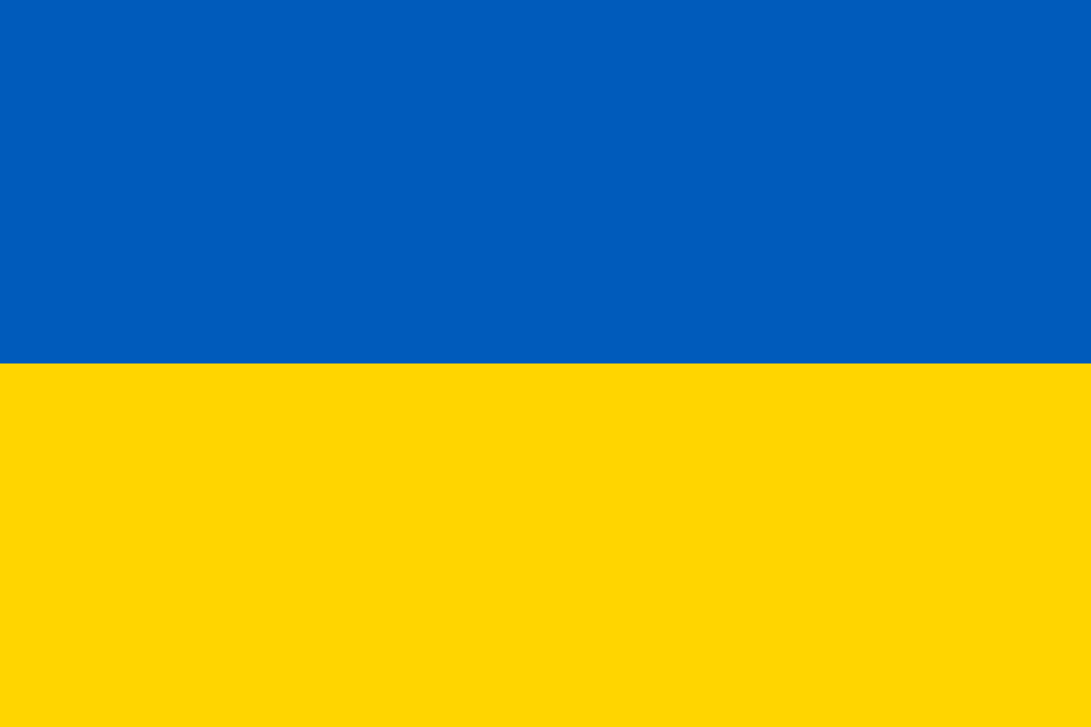 | UKRAINE

 | SECMUN MOCK CONFERENCE 2025 | 

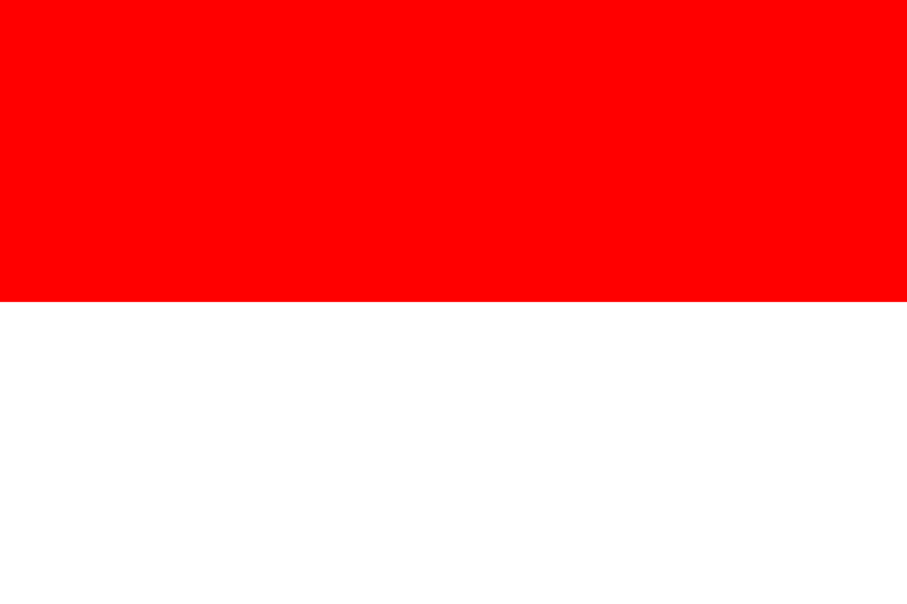 | REPUBLIC OF INDONESIA

 | SECMUN MOCK CONFERENCE 2025 | 

 | ISLAMIC REPUBLIC OF PAKISTAN

 | SECMUN MOCK CONFERENCE 2025 | 

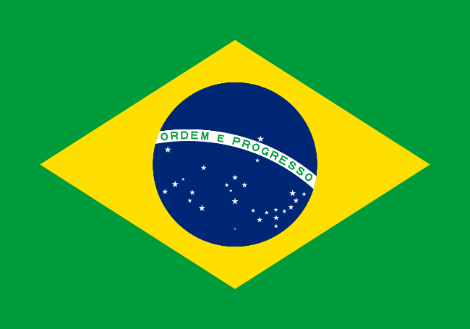 | FEDERATIVE REPUBLIC OF BRAZIL

 | SECMUN MOCK CONFERENCE 2025 | 

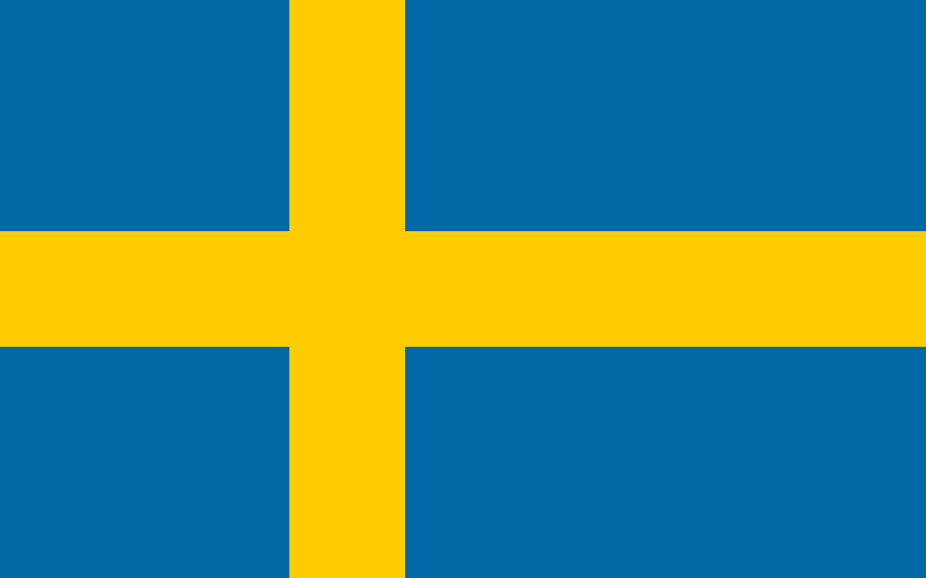 | SWISS CONFEDERATION

 | SECMUN MOCK CONFERENCE 2025 | 

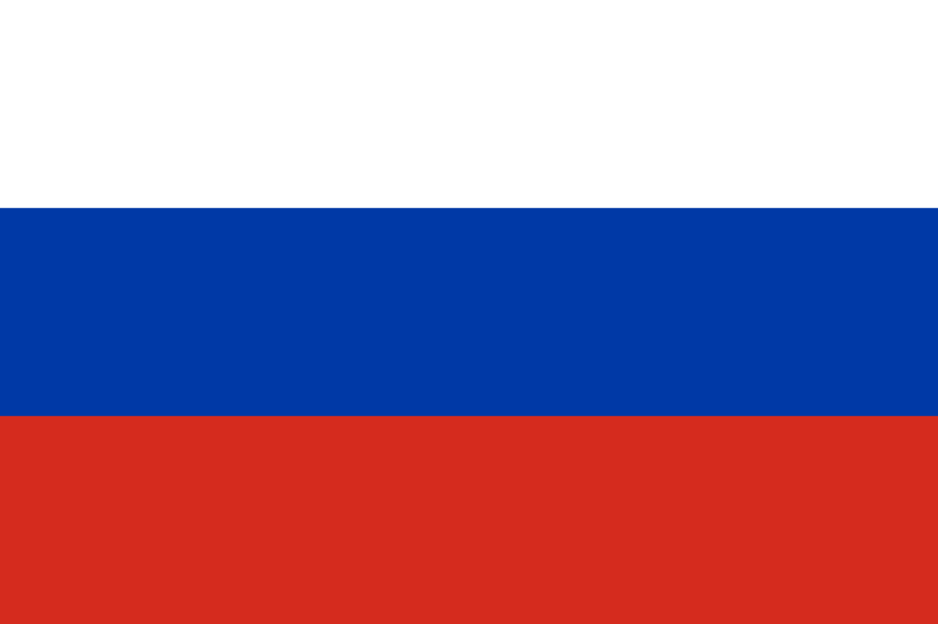 | RUSSIAN FEDERATION

 | SECMUN MOCK CONFERENCE 2025 | 

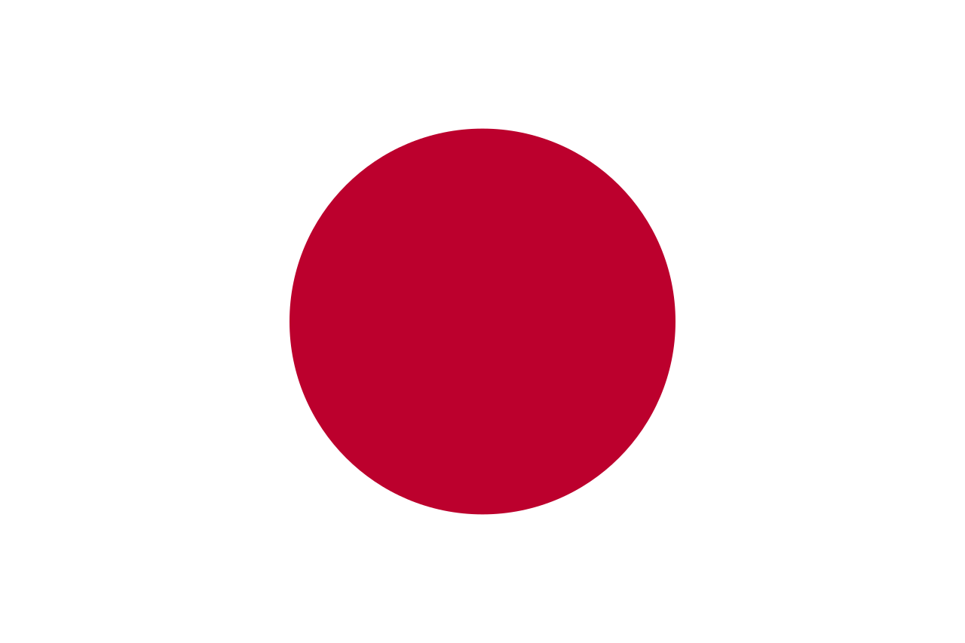 | NATION OF JAPAN

 | SECMUN MOCK CONFERENCE 2025 | 

 | KINGDOM OF SAUDI ARABIA

 | SECMUN MOCK CONFERENCE 2025 | 

 | FEDERAL REPUBLIC OF GERMANY

 | SECMUN MOCK CONFERENCE 2025 | 

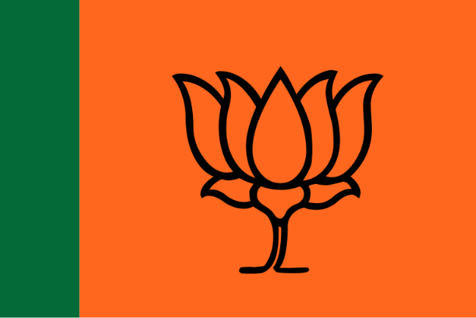 | SHRI NARENDRA MODI

 | SECMUN MOCK CONFERENCE 2025 | 

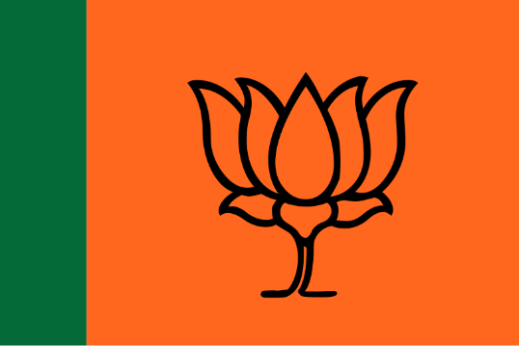 | DR. SUBRAHMANYAM JAISHANKAR

 | SECMUN MOCK CONFERENCE 2025 | 

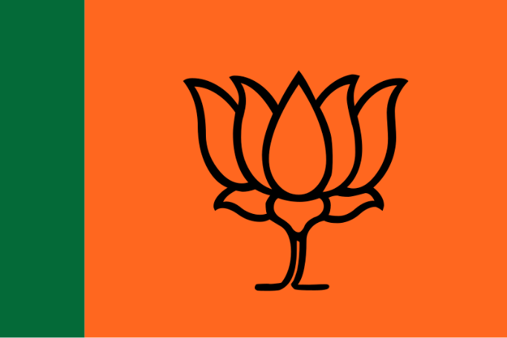 | AMIT SHAH

 | SECMUN MOCK CONFERENCE 2025 | 

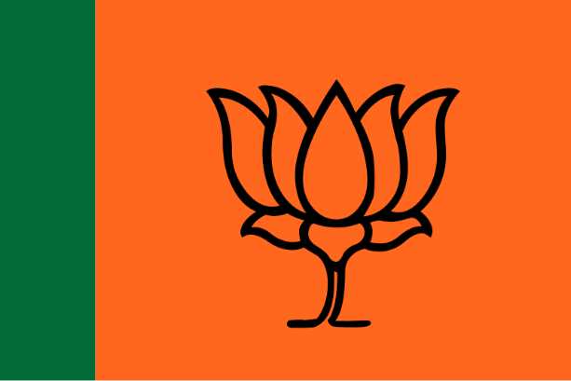 | NIRMALA SITHARAMAN

 | SECMUN MOCK CONFERENCE 2025 | 

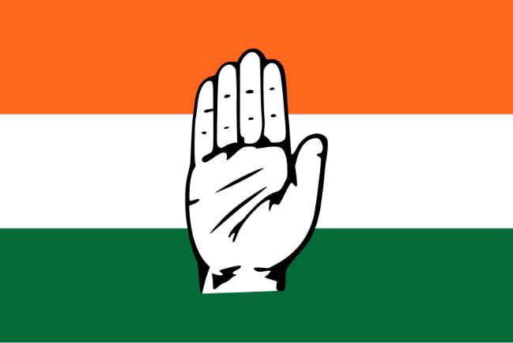 | RAHUL GANDHI

 | SECMUN MOCK CONFERENCE 2025 | 

 | ASADUDDIN OWAISI

 | SECMUN MOCK CONFERENCE 2025 | 

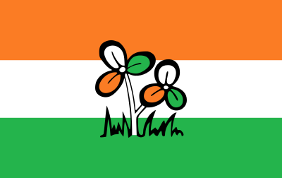 | MAMATA BANERJEE

 | SECMUN MOCK CONFERENCE 2025 | 

 | YOGI ADITYANATH

 | SECMUN MOCK CONFERENCE 2025 | 

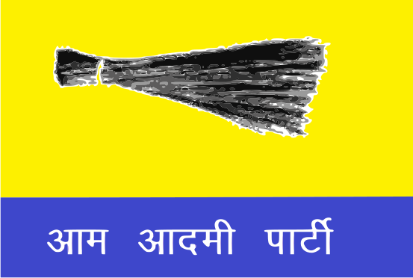 | ARVIND KEJRIWAL

 | SECMUN MOCK CONFERENCE 2025 | 

 | BBC

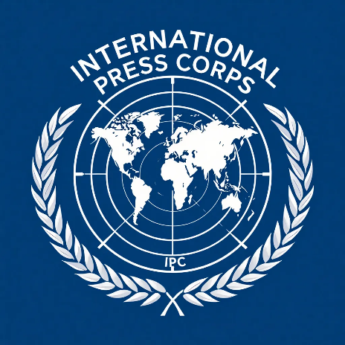 | SECMUN MOCK CONFERENCE 2025 | 

 | AL JAZEERA

 | SECMUN MOCK CONFERENCE 2025 | 

 | THE HINDU

 | SECMUN MOCK CONFERENCE 2025 | 

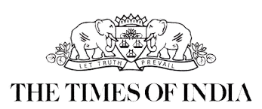 | TIMES OF INDIA

 | SECMUN MOCK CONFERENCE 2025 | 

 | BBC

 | SECMUN MOCK CONFERENCE 2025 | 

 | AL JAZEERA

 | SECMUN MOCK CONFERENCE 2025 | 

 | THE HINDU

 | SECMUN MOCK CONFERENCE 2025 | 

 | TIMES OF INDIA

 | SECMUN MOCK CONFERENCE 2025 | 

CHAIRPERSON

 | SECMUN MOCK CONFERENCE 2025 | 

VICE-CHAIRPERSON

 | SECMUN MOCK CONFERENCE 2025 | 

CHAIRPERSON

 | SECMUN MOCK CONFERENCE 2025 | 

CHAIRPERSON

 | SECMUN MOCK CONFERENCE 2025 | 

RAPPORTEUER

 | SECMUN MOCK CONFERENCE 2025 | 

